Latihan Soal Assignment NLP
- Main Menu
The application menu contains three menus. Validate that the user can only select a number within the available range of 1 to 3.
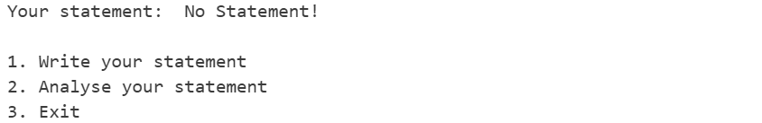
Figure 1. Main Menu
- If user choose menu 1 (“Write your statement”), then:
  - Users will be able to input a statement. Validate that the input must at least contains of 2 words.
  - Program will try to load the model from file “model.pickle”.
  - If the file doesn’t exist, train a new model using Naïve Bayes based on the dataset “financial_dataset.csv”. Then show 7 most informative features, show training accuracy, and save it with format name “model.pickle”.
  - When training the model, make sure to preprocess the dataset by tokenizing the words, remove stop words, remove symbols and number, and either stemming or lemmatizing.
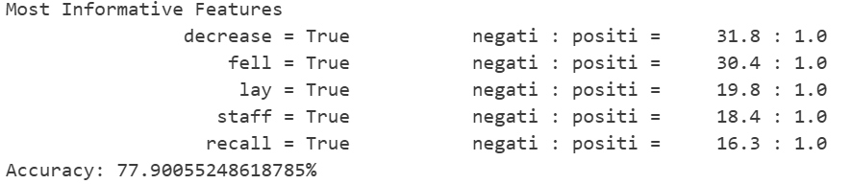
Figure 2. Train Model

- If user choose menu 2 (“Analyze your statement”), then:
  - Check whether there is a statement or not.
  - If there is no statement exists, then show a message to notify the user and redirect user back to main menu.
  - If there is statement exists, then the application will do these following procedures:
        - Show Part of Speech (POS) Tagging.
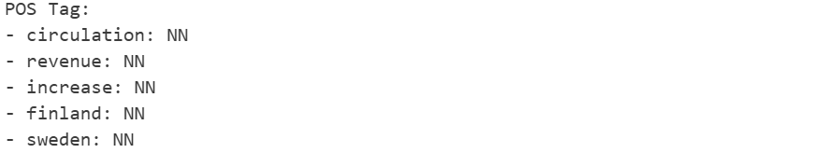
Figure 3. POS Tagging
- Show the synonyms and antonyms of the word in the statement. If the word doesn’t have any synonym or antonym, show message to notify the user.
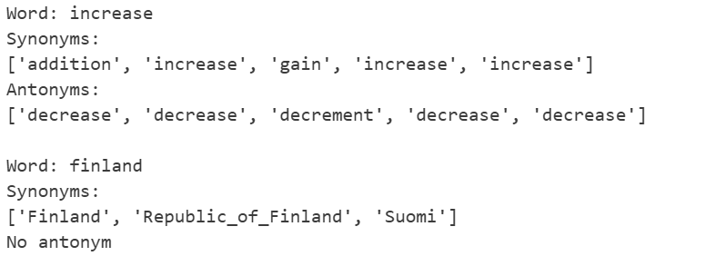
Figure 4. Synonym and Antonym
- Predict and show the result of the statement sentiment.
Figure 5. Prediction Result

- If user choose menu 3 (“Exit”), then terminate the application.

